**Getting Object’s elements**

|  |  |
| --- | --- |
| **Getting Object’s elements** | |
| **Element.children** | **Getting** children inside HTML object. |
| **Element.childElementCount** | **Getting** number of children (only element nodes) present in HTML object, it equivalent to **Element.children.length** |
| **Element.childNodes** | **Getting** number of children (element or text or attribute or comment nodes) present in HTML object |
| **Element.childNodes[index-number].nodeName** | **Getting** name of a child node inside HTML object; is it element nodes or text nodes or comment nodes |
| **Element.childNodes[index-num].tagName** | It has the same function of the above one but the only differ is if the node Is **text**, **undefined** will returns |
| **Element.childNodes[index-num].nodeValue** | **Getting** the ***text*** value of a child node. |
| **Element.childNodes[index-num].nodeType** | **Getting** the type of child node, it returns (**8**, **3**, **2**, and **1**) for (**comment**- **text**-**attribute**-**element**) nodes respectively. |
| **Element.clone(true|false)** | **Copying** element and paste it in another parent. **Note:** **false** (default value) prevent copying process. So use **true** |
| **Element.firstChildElement** | **Getting** first child inside the parent element. |
| **Element.lastChildElement** | **Getting** last child inside the parent element. |
| **Element.firstChild** | **Getting** first child (element or text or attribute or comment nodes) present inside HTML object |
| **Element.lastChild** | **Getting** last child (element or text or attribute or comment nodes) present inside HTML object |
| **Element.parentElement** | **Getting** the parent of a specific child. |
| **Element.parentNode** |
| **Element.nextSibling** | **Getting** the **next** brother (comment, text, element, attribute) node for the current child. |
| **Element.nextElementSibling** | **Getting** the **next** brother (element node only) for the current child. |
| **Element.previousSibling** | **Getting** the **previous** brother (comment, text, element, attribute) node for the current child. |
| **Element.previousElementSibling** | **Getting** the **previous** brother (element node only) for the current child. |
| **Element.focus();** | **Making** focus on specific element. |
| **Element.blur();** | **Removing** focus from specific element. |
| **Element.click();** | **Doing** click on a specific button. |
| **Element.contains(child);** | **Checking** if the parent contains a specific child or not. If it contains, **true** returns otherwise **false**. |
| **Element.clientHeight** | **Getting the height of the element including padding area** |
| **Element.scrollLeft** | **Getting** the number of pixels an element’s content is scrolled horizontally. |
| **Element.scrollLeft = number of px** | **Getting** the number of pixels an element’s content is scrolled horizontally. |
| **Element.scrollTop** | **Setting** the number of pixels an element’s content is scrolled vertically. |
| **Element.scrollTop = number of px** | **Setting** the number of pixels an element’s content is scrolled vertically. |
| **Element.clientLeft** | **Getting** the left width of the element’s border & scroll bar. |
| **Element.clientTop** | **Getting** the top width of the element’s border. [**Note:** there is no scroll bar in the top of element] |
| **Element.style.property** | **Getting** CSS property of specific element. |
| **Element.style.property = ‘value’** | **Setting** CSS property of specific element. |

**Example:** on children, childElementCount, childNodes.

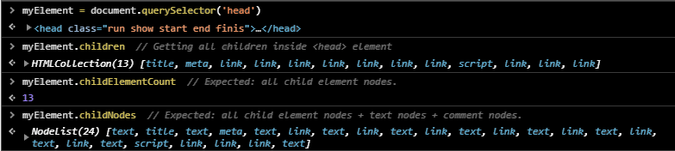

**Example:** on firstChild, lastChild, firstElementChild, lastElementChild.

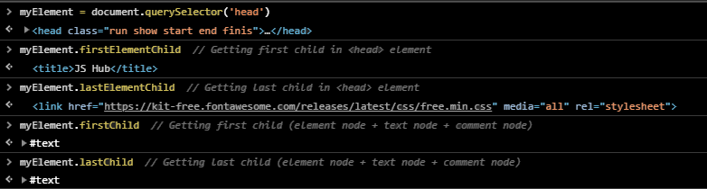

**Example:** on **Element.childNodes[index-number].nodeName & Element.childNodes[index-number].tagName**

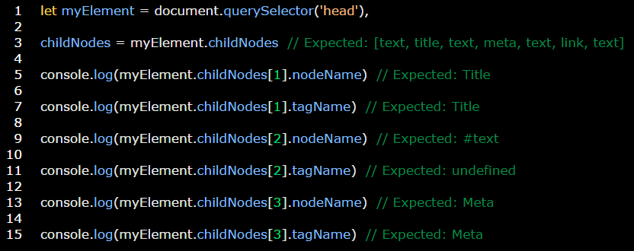

**Example:** on **Element.childNodes[index-num].nodeValue**

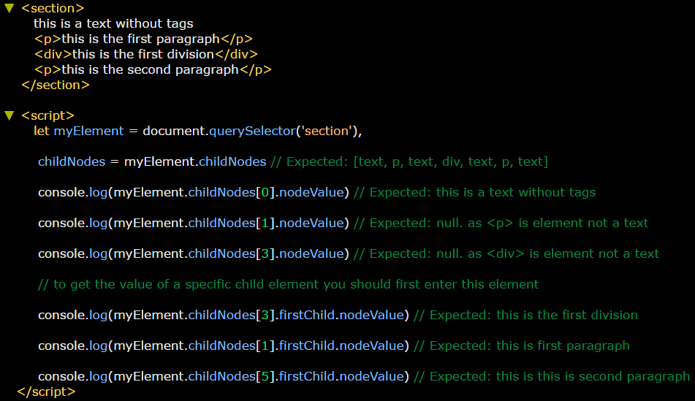

**Example:** on **Element.childNodes[index-num].nodeType**

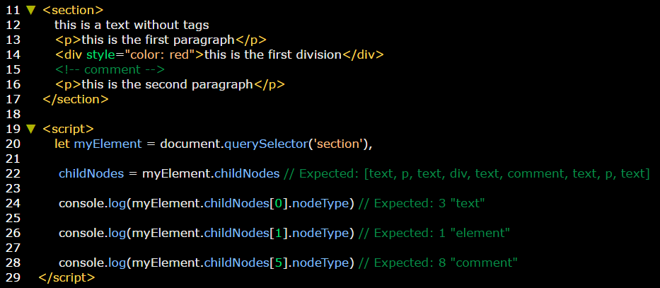

**Example:** on cloning elements.

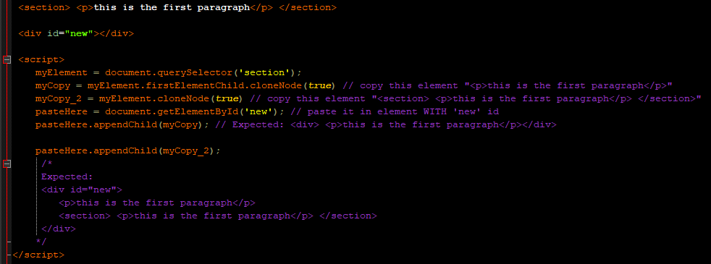

**Example:** on parentElement.

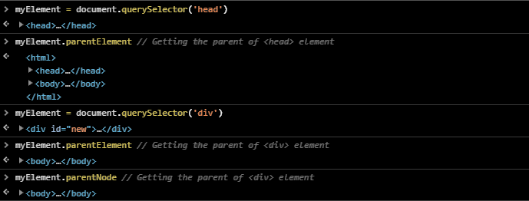

**Example:** on making screen pop up by using parentNode and onclick order.

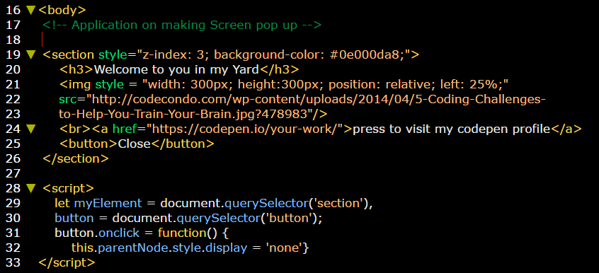

**Example:** on next and previous siblings.

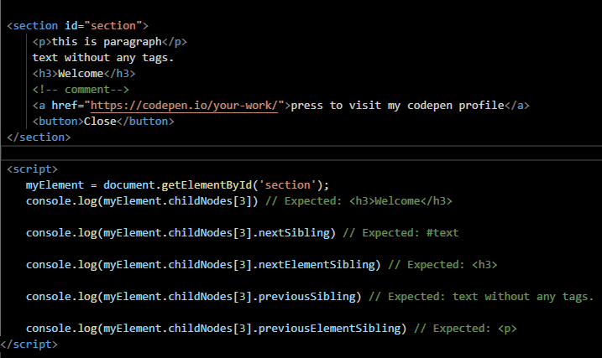

**Example:** on focus() and blur() **functions.**

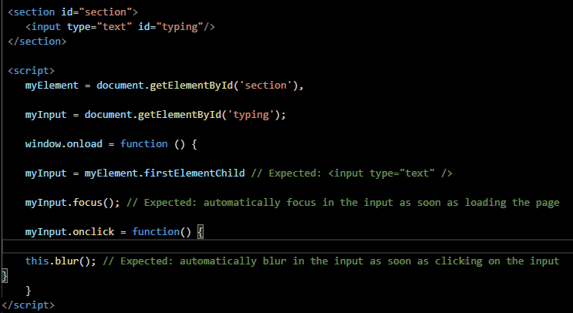

**Example:** on click(); function.

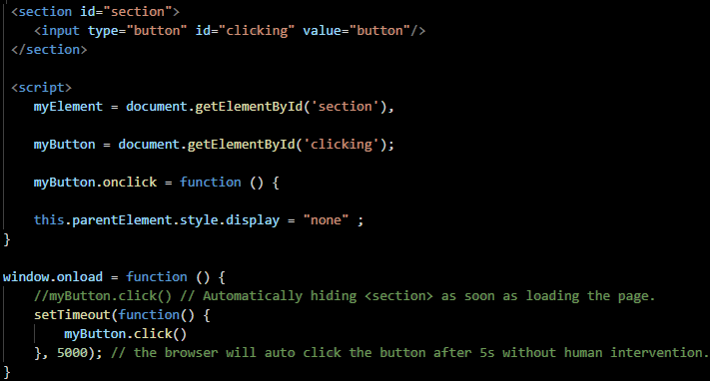

**Example:** on using contains(parameter) function

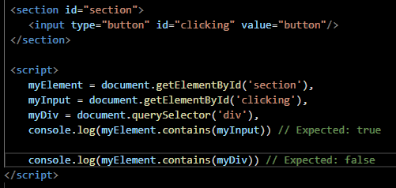

**Example:** on scroll left and top.

**Example:** on clientLeft and clientTop.

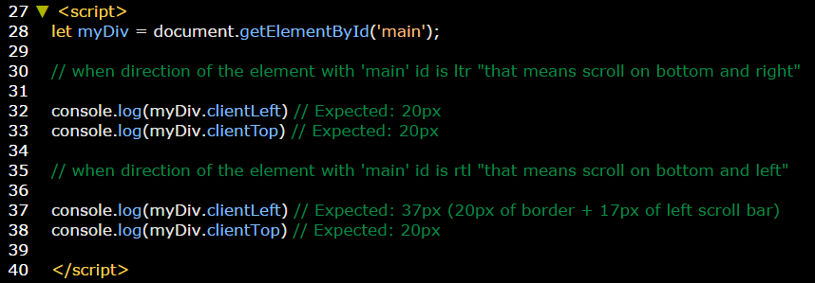

|  |  |  |  |  |  |
| --- | --- | --- | --- | --- | --- |
|  | **Viewable area** | **Padding** | **Border** | **Scroll bar** | **Margin** |
| **Element.clientHeight** | **✓** | **✓** | **🗶** | **🗶** | 🗶 |
| **Element.clientWidth** | **✓** | **✓** | **🗶** | **🗶** | 🗶 |
| **Element.offsetHeight** | **✓** | **✓** | **✓** | **✓** | 🗶 |
| **Element.offsetWidth** | **✓** | **✓** | **✓** | **✓** | 🗶 |
| **Element.scrollHeight** | **✓** | **✓** | **✓** | **✓** | 🗶 |
| **Element.scrollWidth** | **✓** | **✓** | **✓** | **✓** | 🗶 |

**Example:**

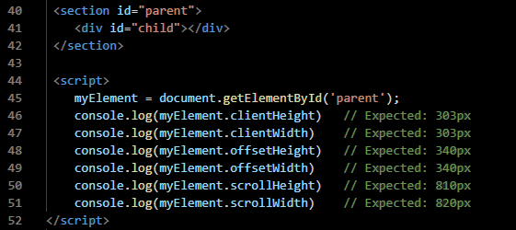

**Example:** on Element.style.property.

